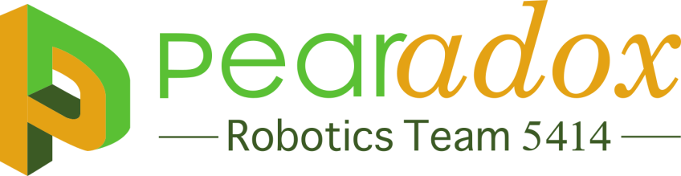
Chairman’s Award Short Answer 2015
Team’s Initiatives to help start or form other FIRST Teams
Our initiative to help form other FIRST teams is seen in our community outreach. We are representing FIRST to the community, local companies and our school board to raise awareness of the benefits of these programs. Our current involvement with other FIRST teams is seen in our mentorship of a local FTC team and the team activities with local FRC teams such as our kick-off event, Spare Parts movie night and Week Zero collaboration.
How would your team describe FIRST
To us, being in FIRST is not about winning nor beating other competitors. Instead, being in FIRST defines us as a team. It teaches us teamwork, cooperation, and engineering. FIRST in not only about building a robot, it’s about helping community, promoting STEM, and learning about business. These core value aid us in becoming not only successful towards our goal for the Rookie All-Star but also change each of us into becoming a better person.
Team’s Initiative on assisting other FIRST teams
As rookies we have donated our field pieces to multiple Week Zero practice events to help other FRC teams practice before Bag and Tag day. Some of us also help mentor local FTC teams and volunteered at an FLL tournament hosted by Spectrum to help make the event successful. We also invited Team 1255 to our kick-off event at our high school to save on travel expense and network with other teams while they also listened to our guest speaker from NASA to boost enthusiasm about STEM.
Impact of FIRST program on team members
Our members have improved on team working and leadership, speaking skills, and have brought 3 high schools together to form a single robotics team. Our team has given many high students an opportunity to learn marketing, networking, volunteerism, communication between peers and mentors, and has also given them leadership opportunities that will be critical life skills. People in robotics have an opportunity to meet people that share their interest in innovation and efficiency.

Describe the team’s efforts to make new FRC teams
During our trailer donation, the CEO of United Safety, Lee Whitaker, was inspired by our team’s presentation realizing our team does more than just build a robot. He is looking in to starting FRC teams in other corporate locations: Calgary & Dubai. Pearadox decided to write a Rookie Starter Guide explaining team formation, management, and providing sustainability for the future. Our intent is to provide information to these new rookie teams to start them down a sustainable path to success.
Other matters of interest
We have exceptional team leaders that monitor and help students in their work. This gives team leaders the ability to hold students accountable and responsible to what they were assigned. Instead of acting out or getting lost and waiting for help from the mentors, team leaders are able go in and help. This allows mentors to concentrate on one question instead of being bombarded with multiple and it also keeps the students on task.
Describe your team sponsors
An FRC team must build and sustain strong partnerships with companies and organizations. Our team does this by being active in the community and remaining in constant communication with our sponsors. Our foremost sponsor is United Safety a global safety equipment company, provided us with hard hats, goggles, a trailer, and $5000. NRG is an energy provider who donated $10000 and NASA, a government program, donated $5000 and a grant. Kuraray, a chemical company, presented us with $1000.
Describe how your team members act as role models
Members of our team help each other with homework and work hard to keep peers on task. We handle difficult situations very well. We brought 3 high schools together and introduced FRC to Pearland for the first time. We have students who mentor lower grades and aid in FLL & FTC teams, taking time out of their own schedule to encourage and teach the youth about STEM and robotics. People in our robotics teams are role models that can manage their time well and have time to help people in need.
Describe your relationships with your community and sponsors
Our actions at our Christmas parade and YAPFEST (Young Automation Professionals) have greatly impacted our community. At YAPFEST Team 5414, and Spectrum, Team 3847, presented to companies and college students what FIRST is. At the Christmas parade, we made it clear to citizens that there was a district high school robotics team starting and we told the Cub Scout troops about FIRST. As Superintendent Kelly put it while driving our robot, “People must know about this [program]”.
When it comes to innovation, our team makes new and fresh ideas a top priority. Our team decided to attend a movie about a high school robotics team called Spare Parts. Other FRC teams also joined us such as High Voltage, Robonauts, and Blarglefish. We raised awareness for our robotics team as well as FIRST by displaying our banner in front of the movie theater. We also sent a holiday e-card to our sponsor, Kuraray. This lead to the CEO of Kuraray mentioning our team in the nation-wide teleconference.
How your team works with other FIRST teams to serve as mentors to younger or less experienced FIRST teams
Our team has helped teams such as team 1255 with developing pit scouting content for this year’s game. We also gave 1255 suggestions on how to prepare for judges questions in the pits. We are currently developing content for a Rookie Starter Guide. We feel very fortunate to have had help from many veteran Houston teams and we hope to be a resource for rookies in the future to be successful. With emphasis on teams that may be started by the United Safety CEO who was inspired by our team.
Describe your sponsor partnerships
We believe the key to sustainability is strong sponsor partnerships. We have sent out holiday e-cards to our corporate sponsors, weekly Facebook updates, and hosted multiple events at our school. One event was a trailer donation with United Safety’s CEO as well as our Open House where sponsors, community leaders, the public and district staff were invited. We frequently post and tweet thank you to those who often share or re-tweet us to spread FRC awareness.

